Here are some of the ways we measure success of our educational & primary prevention programs:
- Collect the following information about participation in specific trainings or events:
  - Track the number of attendees
  - Make a note of what type of engagement is used. For example, in virtual trainings, engagement can look like:
    - use of chat
    - use of reaction buttons
    - use of camera
    - coming off mic to share verbally
  - Calculate the percentage of attendees/participants who attend optional initiatives
    - ex: 100% partner organizations attended mandatory training; also surpassed our trainee goal by 160% (78 trained/48 targeted)

- For participant evaluations, include scaled questions (strongly agree, agree, neither agree nor disagree, disagree, strongly disagree) to measure or training quality:
  - I felt safe at [event]
  - This [training] was engaging
  - This [training/resource] was helpful
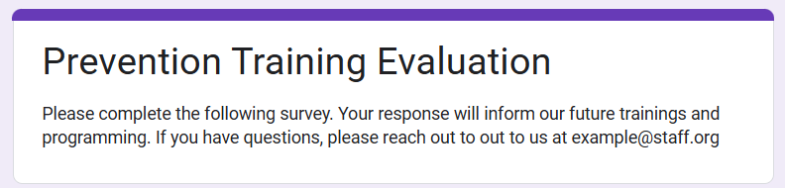
  - This content was new to me (this is moreso a measure of need, but showing that a need is being addressed constitutes success to us)
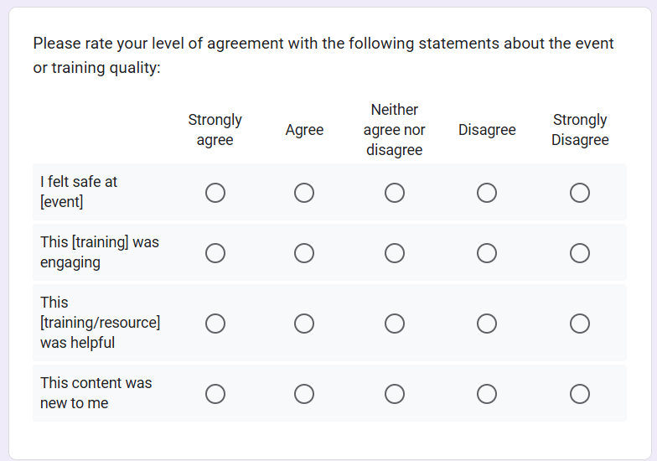
See the screenshot from a sample survey in an evaluation in Google Forms, a free survey platform:

- Evaluate level of understanding of resources shared or by requesting that participants rate their level of agreement (strongly agree, agree, neither agree nor disagree, disagree, strongly disagree) with the following statements:
  - I am confident in using [specific element of a resource]
  - I am confident I am able to explain [resource] to anyone who asks me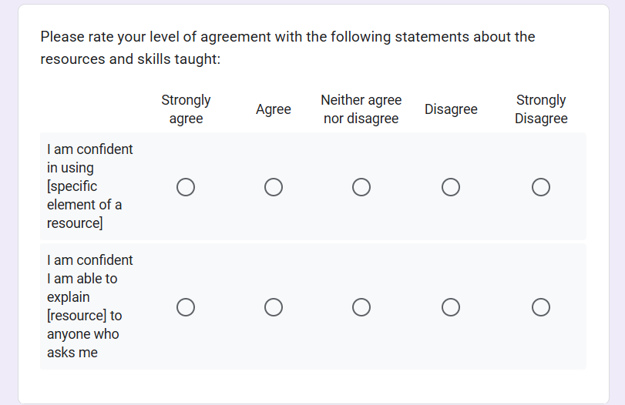
- Measure community members' self-reported use of resources: in post-event surveys, list out resources available & ask participants to check which resources they used or shared with a peer.
  - For example: Check all the resources that you have used or shared with a peer:
__ [Resource 1]
__ [Resource 2]
__ [Resource 3]
__ [Resource 4]
__ [Resource 5]
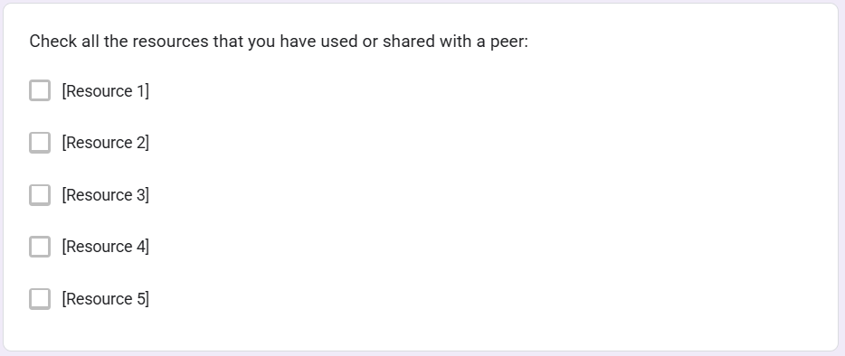

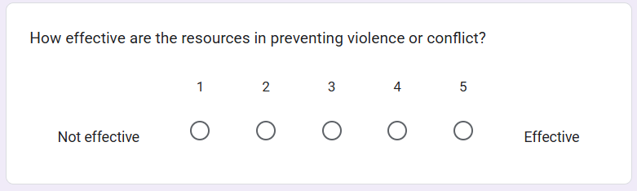
- Solicit community members' evaluation through likert scale ranking of the efficacy of resources/expectations in preventing violence or conflict (1 - not effective, 5 - effective).

