
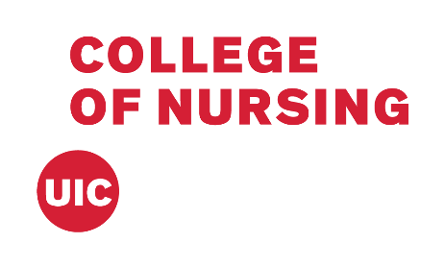

Y-ACT
TRANSFORMING LIVES AND PREVENTING VIOLENCE

COMMUNITY DISCUSSION GUIDE FOR BUILDING HEALTHY, SAFE AND PEACEFUL COMMUNITIES

“champions for change,
creating safer communities”
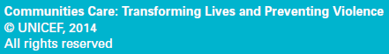
COMMUNITY DISCUSSION GUIDE FOR BUILDING HEALTHY, SAFE AND PEACEFUL COMMUNITIES
Contents
Welcome 4
A participatory, learner-centered approach 5
Structure of the discussion guide 6
Human Rights 9
Encouraging participation 10
Materials 10
Opening and closing each meeting 10
Checklist 11
Phase 1: 12
Week 1: Getting to know each other & A World We Hope For 12
Topic 1: Welcome and Introductions 14
Topic 2: Working Together 16
Topic 3: Sharing our Hopes and Dreams 18
Topic 4: Our Vision for a Healthier, Safer, Peaceful Community 19
Phase 2: 21
Week 2: Human Dignity & Human Needs 21
Topic 1: What is Human? 23
Topic 2: Religion, Culture, and Human Dignity 25
Topic 3: Different Types of Needs and Wants 27
Topic 4: Needs for a Healthy, Safe, and Peaceful Life 29
Week 3: Fairness 31
Topic 1: Fair Rules 32
Topic 2: Rules in our Family and Community 33
Week 4: Non-Discrimination & Human Rights 34
Topic 1: Discrimination 35
Topic 2: Promoting Tolerance and Non-Discrimination 37
Topic 3: What are Human Rights 38
Topic 4: Basic Human Rights in our Community 40
Phase 3: 42
Week 5: Power 42
Topic 1: Exploring Empowerment and Disempowerment 43
Topic 2: Different Sources and Uses of Power 45
Week 6: Violence 47
Topic 1: Violence Throughout Life 48
Topic 2: Mapping Violence in Our Community 50
Week 7: Gender-Based Violence 51
Topic 1: What is Gender-Based Violence? 52
Topic 2: Stories about Gender-Based Violence 54
Week 8: Beliefs and Norms about Gender-Based Violence 56
Topic 1: Community Beliefs about Gender-Based Violence 57
Topic 2: Sharing Personal Beliefs 59
Phase 4: 61
Week 9: Rules for Behaviors & Change 61
Topic 1: Affirming Positive Rules 62
Topic 2: Building on Positive Rules 63
Topic 3: Ideas for New Rules 64
Topic 4: What Can we Do? 65
Week 10: Making an Action Plan & Communicating our Commitment to Others 67
Topic 1: Brainstorming Actions 68
Topic 2: Agreeing on Action 70
Topic 3: Reaching Out to Others 71
Topic 4: Making a Public Commitment 73

Welcome
Welcome to the Y-ACT: Transforming Lives and Preventing Violence Program Community Discussion Guide for building healthy, safe and peaceful communities. The Discussion Guide provides Community Facilitators with information and suggested weekly plans to lead a 10-week guided discussion and dialogue process with core groups in communities where the Y-ACT Program is being implemented.
The Y-ACT community discussions aim to bring the issue of violence against women and girls, into the open and to motivate community members to take action together to prevent violence in the following ways:
- Help different people in the community reflect on and affirm shared values of respect for human dignity, fairness and justice.
- Help people talk about the issue and come to their own conclusions about it.
- Build a shared vision of a violence-free community.
- Encourage discussion, debate and analysis in the groups and in the wider community about violence against women and girls.
- Enable people to identify positive social norms that promote safety and security and question harmful norms that contribute to violence against women and girls in families and communities.
- Inspire people to become change makers and commit to taking action against sexual violence in their community.

- Help people talk about the issue and come to their own conclusions about it.

A participatory, learner-centered approach
This Discussion Guide follows the Y-ACT Program theory of change, which is based on UNICEF’s framework for social change using a social norms perspective.
This framework uses participatory discussion and dialogue to bring people together to build awareness and consciousness about shared values of respect for human dignity, fairness and justice; to connect their experiences of violence and injustice to the experiences of others; and to analyze how harmful social rules and expectations of men and women contribute to violence and injustice. Participatory discussions empower people to find solutions to their problems and to know that together they can change their reality.
Effective participatory discussions are built on a foundation of trust, understanding and respect between all group members and enable people to use their head and their heart to listen to and really hear the experiences, aspirations, beliefs and ideas of others in their community.
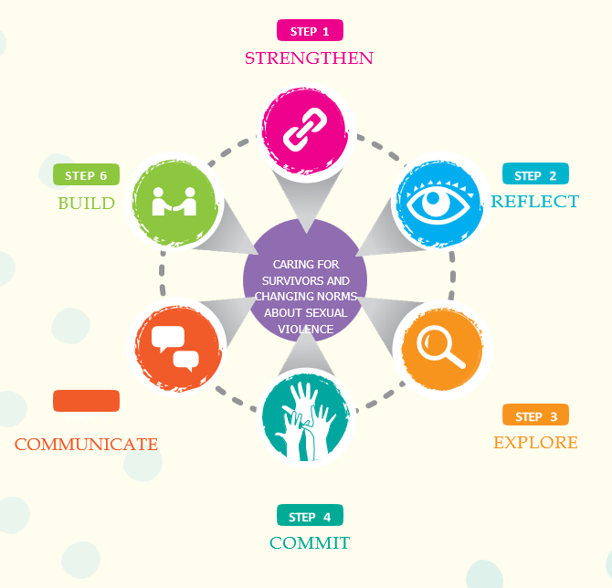

Structure of the discussion guide
The Discussion Guide is carefully structured based on research and experience from similar Programs, on theories of group dynamics and adult learning, and on the advice of UNICEF social norms experts.
You will see in the figure on page vi there are four phases which can be summarized as getting acquainted, exploring values, reflection and understanding, and exploring options. Each one is important and builds on the one before.

It’s very important to use the first weeks to foster a group culture of trust and open communication so that you can set a strong foundation for the second phase, which looks at core human values and how they relate to people’s common aspirations and to their own cultural and religious frameworks.
You may wonder why so much time is given to exploring and discussing concepts such as human dignity, human needs, fairness and discrimination.
Participants will learn best and get the most out of the discussions when:
- They feel valued and respected.
- The discussion actively involves them.
- The activities and discussions fulfil their needs.
- They accept responsibility for their learning.
- Their learning addresses ideas, feelings and actions.
- New information is related to what they already know.
- The information is repeated and reinforced.
- Learning occurs in small groups.
- Their contributions are valued

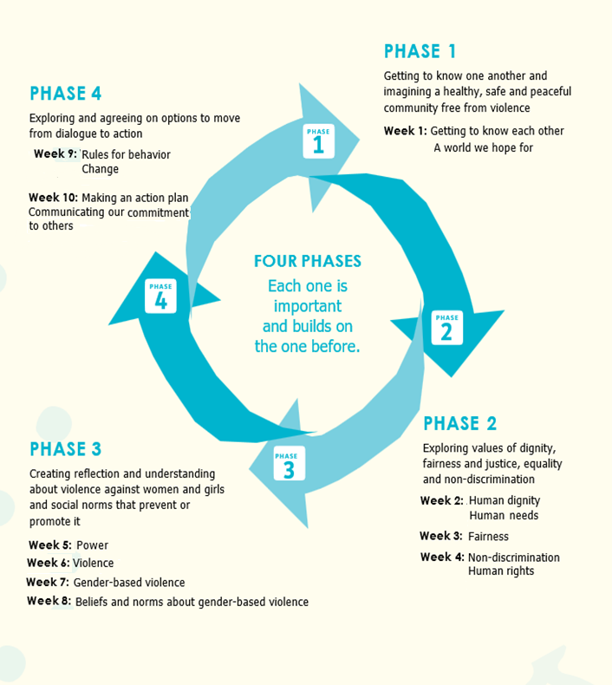
Structure of the Discussion

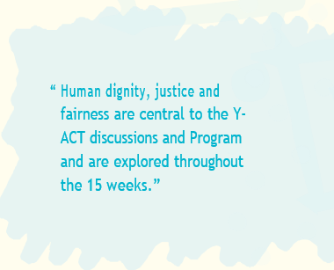
Experience from similar Programs tells us it’s easy to underestimate how much time it can take for people to examine and discuss these abstract concepts and relate them to their own lives and aspirations. This process lies at the heart of the Y-ACT Program’s approach, and this phase lays the groundwork for community-led change by giving people space to develop a framework for dealing with the problems they face.

The third phase concentrates on creating understanding and dialogue about violence against women and girls and social norms that prevent or promote it. Before discussing a sensitive issue like gender-based violence, you need to slowly build safety and trust in the group and develop a framework for analysis. You need to be clear from the very first group meeting that the Program aims to make changes to prevent violence, but you shouldn’t feel that it has to be discussed in detail in the early weeks. On the other hand, if participants wish to discuss gender-based violence in the context of earlier meetings, of course you should feel free to do so.




The fourth and final phase centers on identifying changes that group members can make and actions that they can take. It is not expected that each group will develop a complete action plan in one week; more time will be needed than that. However, it is important that each group has the opportunity to deliberate and identify a commitment that its members can make together and actions they can take to implement that commitment.


The research will arrange more time for action planning after the discussion groups have finished and invite participants from the groups and other community stakeholders to develop a plan together based on the commitments, ideas and strategies generated by the different groups during the discussions.




The Discussion Guide covers 10 weeks of suggested meetings. It’s important that people are given enough time to engage with and build an abstract conceptual framework and relate it to their own lives. For this reason, ample time is given each week to exploring key ideas and concepts. New concepts and information are introduced each week and then repeated, reflected on and discussed further.

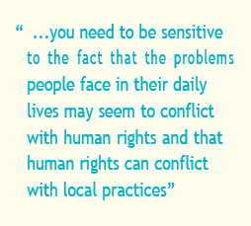
Human Rights

Human dignity, justice and fairness are central to the Y-ACT discussions and Program and are explored throughout the 10 weeks, in particular during the second phase, in which topics of human dignity, human needs, fair rules and non-discrimination are examined in the context of cultural and religious frameworks. Other core values are equality, non-violence, participation, inclusion, accountability and responsibility. 
While these values are based on human rights principles, the Discussion Guide only dedicates one week to human rights. While knowledge of our human rights is a critical first step in claiming them, if the topic of human rights is too sensitive to discuss in your community, you can discuss human rights values and principles within local religious and cultural frameworks instead. To do this, Program managers will need to prepare guidance on how to conduct these meetings.


When you discuss human rights with a group, you need to be sensitive to the fact that the problems people face in their daily lives may seem to conflict with human rights and that human rights can conflict with local practices. You should not avoid discussing these issues, but rather encourage open discussion and debate. In doing so, you will help participants to think critically about human rights and their relevance to their lives and communities. At the same time that human rights ideals can conflict with people’s lived experiences, they can also be used to inspire individuals to see themselves as a part of a larger system in which they are empowered with rights and are entitled to take actions to claim those rights. If you include the meetings on human rights, it’s important to enable reflection about the question “what can I do with these rights?”
You might also choose to integrate human rights throughout all the sessions, using the key concepts and discussion questions in week 4 throughout other topics and meetings.

Group size and composition
The Y-ACT Toolkit contains guidance on whom and how many people to include in each group; however, the research team and community partners will decide what is most appropriate in each context. It is suggested that each group start with about 12 people, because it is normal for groups to lose a few members as they progress. Given the number of people each group will start with, it is recommended that each group has a lead and a co-facilitator to assist with the discussion process.

Encouraging participation
To keep people interested and participating in the group discussions you need both interesting and relevant content and good facilitation by facilitators, so that people feel engaged and enjoy coming. Information Sheet 1 Participatory Activities has some suggestions for promoting participation.
As well as making sure the content is relevant and interesting and that facilitators have good facilitation skills, the research team also needs to think through other strategies you can use to keep group members participating. What have you done to keep people engaged and motivated in other Programs? What have other organizations implementing similar Programs done, and what can you learn from them?
In some communities that have implemented non-formal education Programs such as this one, group leaders have visited group members on the morning before each meeting to encourage them to attend and visited group members who have stopped coming to meetings to find out why and to help overcome any obstacles to attending.
Important questions for the team to answer before you begin the discussions are:
- What strategies do we need to put in place to encourage people to attend meetings each week?
- What other organizations have experience in our context that we can learn from?
- How will we respond if people stop attending?

Materials
For every meeting, you will need plenty of flipchart paper, a flipchart stand, markers, pens and tape. When additional materials are needed for particular activities, they are listed in the overview at the beginning of each week.

Opening and closing each meeting

You will need to agree with each group you work with on a plan for opening and closing each meeting. Some groups may choose formal opening and closing rituals, such as prayers or songs, while other groups may prefer to begin each meeting with a different warm-up activity and to close by inviting a different member of the group to make some remarks. Other groups may choose a combination of options. The important thing is that group members decide and have a sense of ownership and belonging.

Make sure you give everyone an opportunity to share their reflections at the beginning of each meeting. It may be helpful to call on those who speak less after a few weeks when they may feel more comfortable.
xi

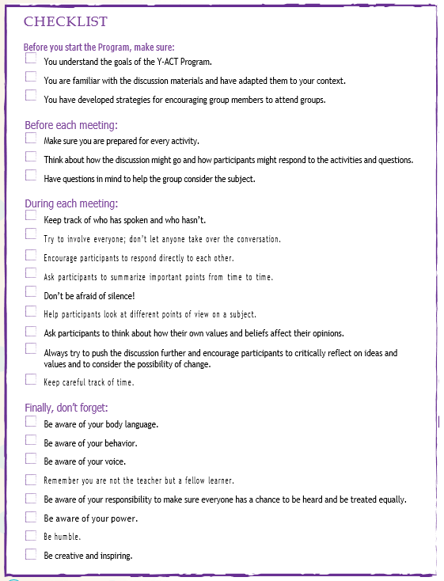
Checklist

