Lifetime Spiral of Gender Violence
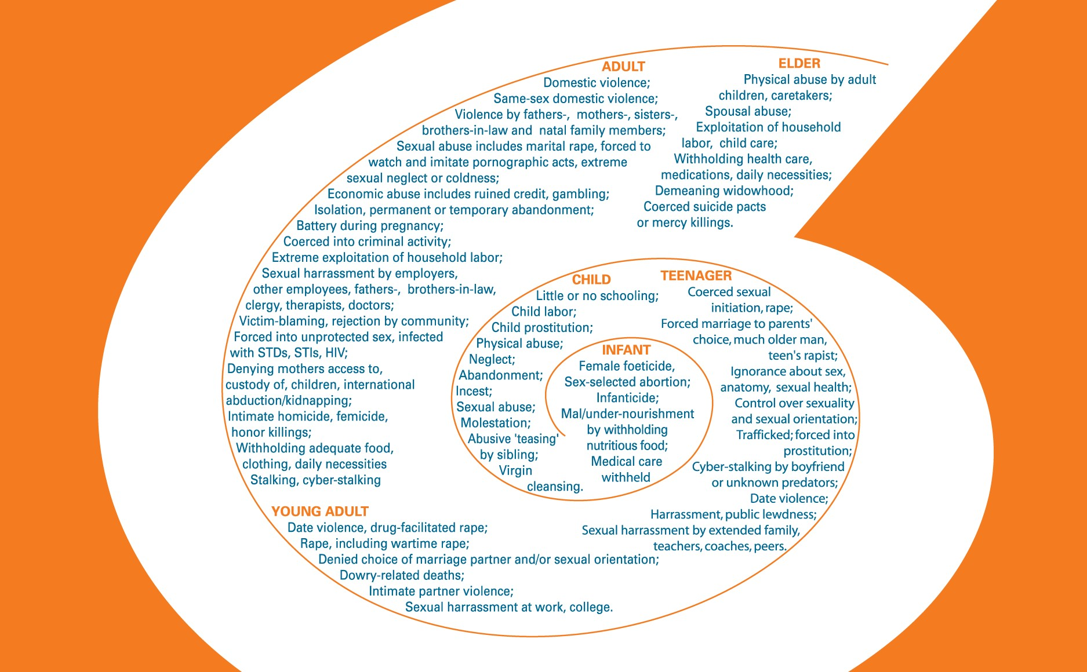
Circle the types of violence that
- You have experienced; write "ME" next to it
- Your family and friends have experienced; write "F" next to it. Cross out the types of violence that do not apply to your community.
If you wish to, please write in your ethnicity: ___________________

Lifetime Spiral of Gender Violence
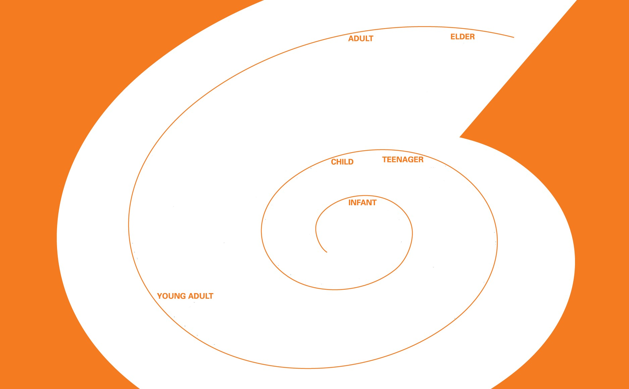
Do you have anything to add? Permission to adapt this script for different communities is granted.
The Asian & Pacific Islander Institute on Domestic Violence would appreciate if you let us know how you have used the Lifetime Spiral of Gender Violence and if you adapted it, please send us the adapted version at info@api-gbv.org

